Exp. Exp. 1. Simulation of scattering and absorption of Multi-layer Sphere and
Core-Shell Nanoparticle using Mie-Plot tool

Output:
Scattering and absorption spectra for a core–shell nanoparticle.
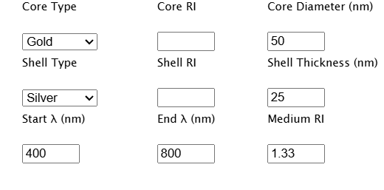
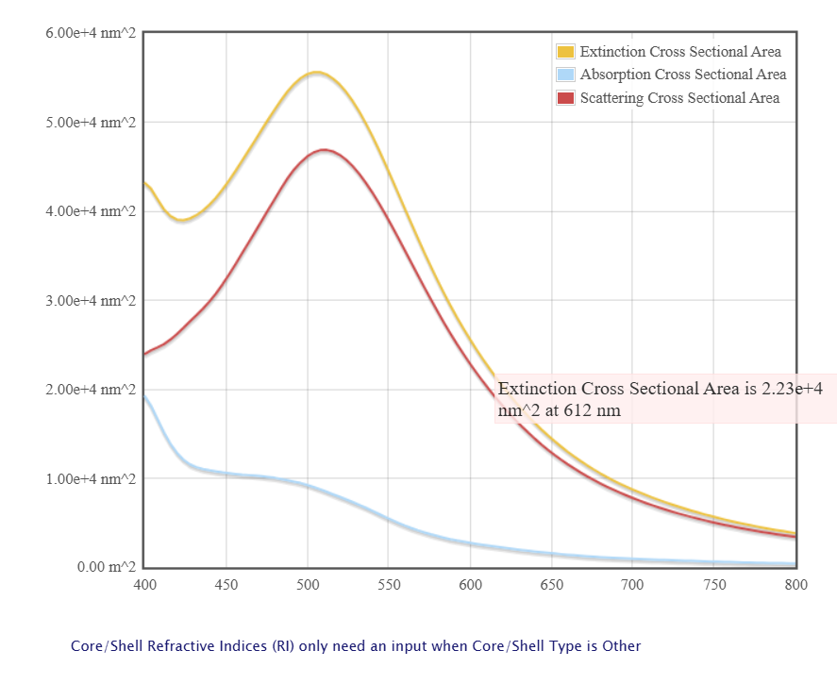

Case Study 1: Scattering and absorption spectra for a single-layer sphere (core only).

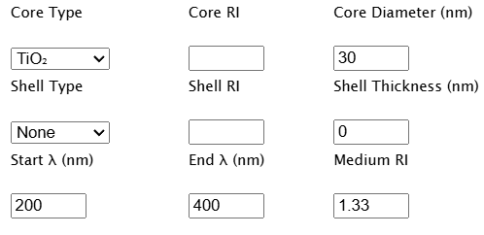
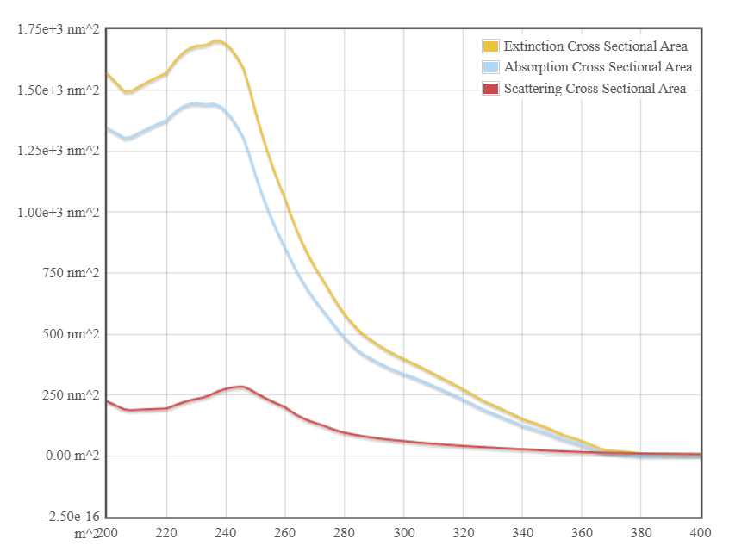

Case Study 2: Simulate the optical response of a gold (Au) nanoparticle of 50 nm diameter
in water medium.
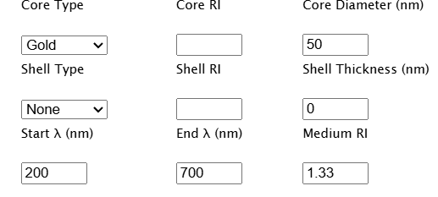

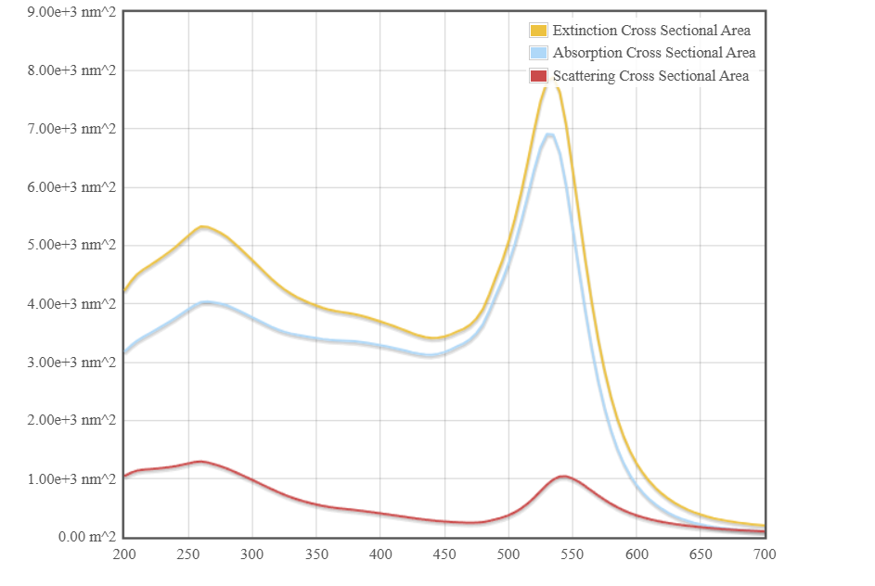
Case Study 3: Simulate a core–shell nanoparticle with a gold core (30 nm) and silica shell
(10 nm)
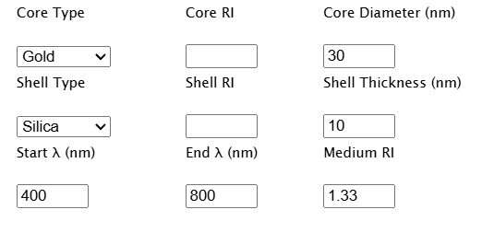
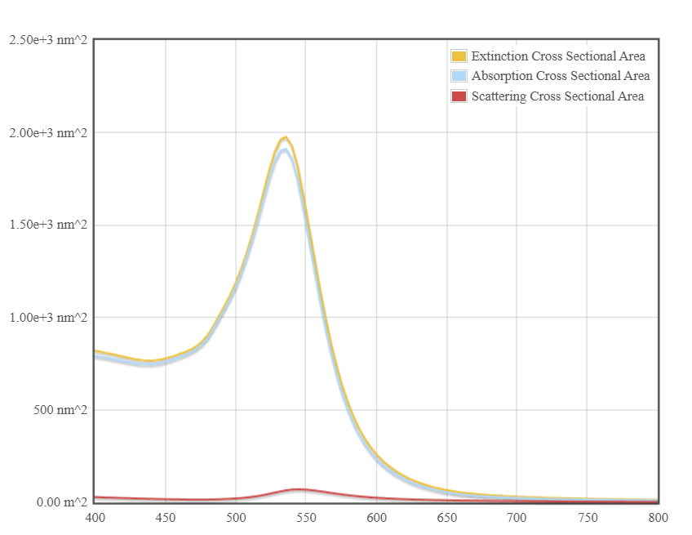

8.Simulation of VI Characteristics of FINFET, CNTFET and GFET
using NanoHub
- FINFET

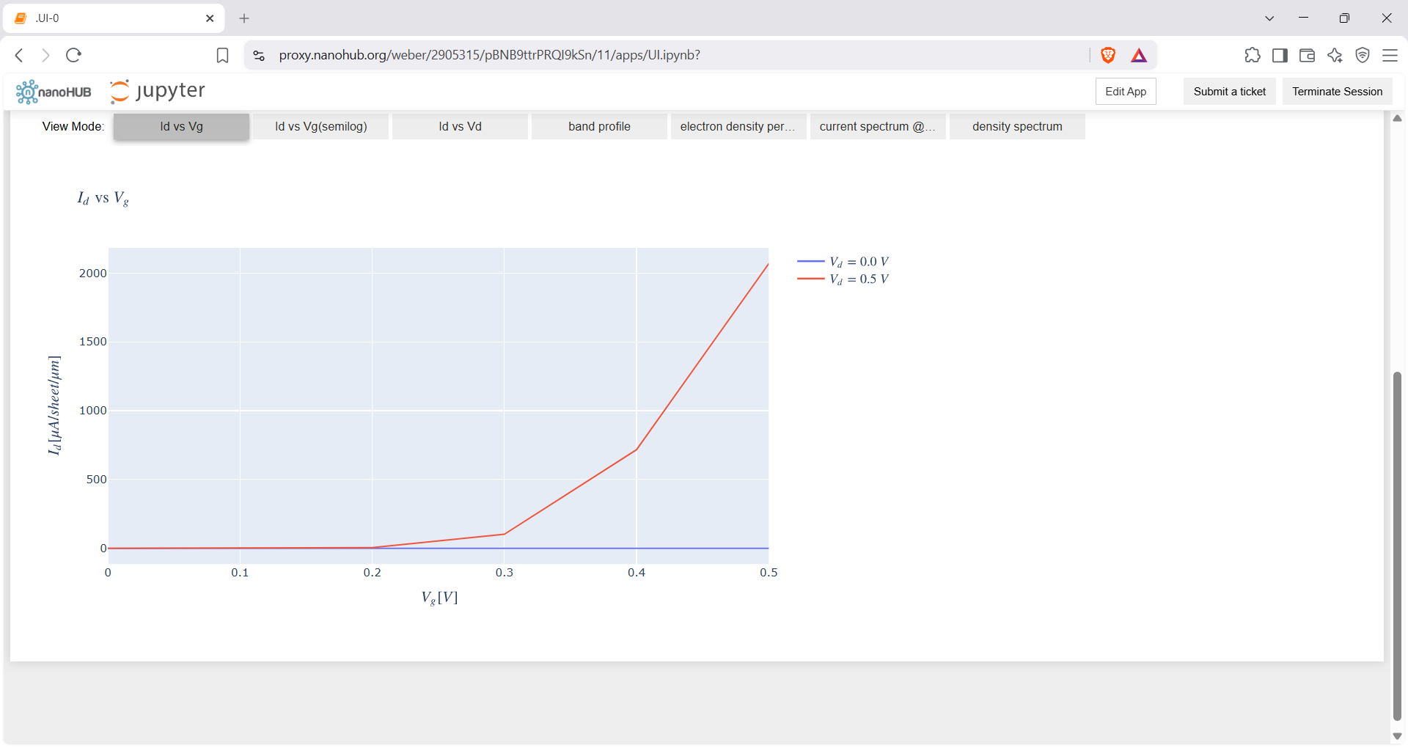

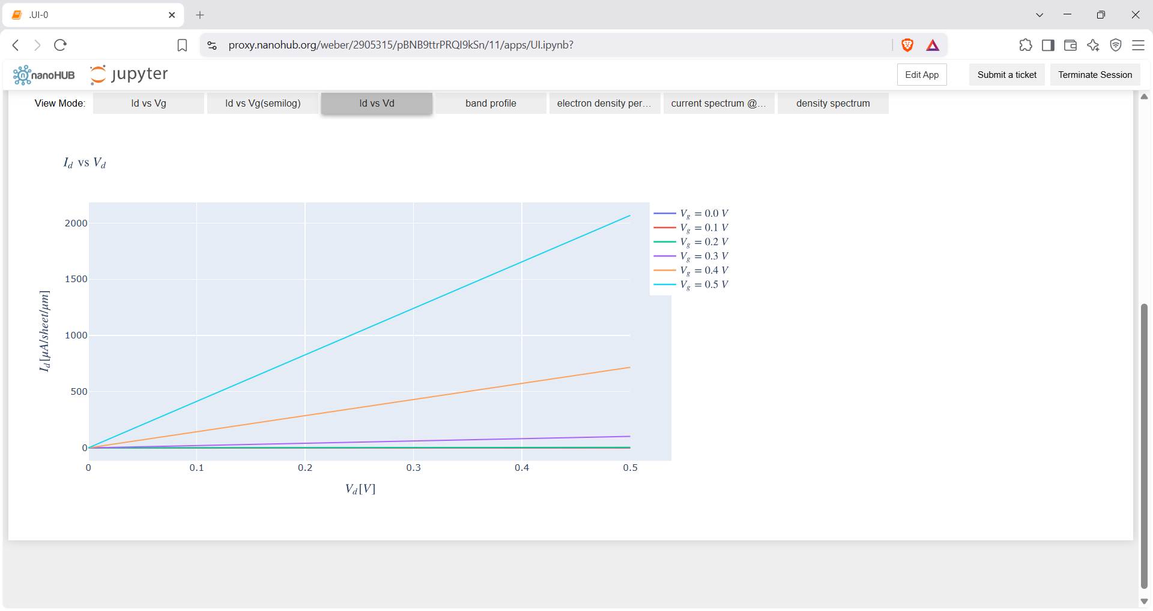

Case Study 1: Simulate & obtain the current spectrum characteristics for the last bias point of
FinFET. Analyze the performance for different Oxide layer thicknesses

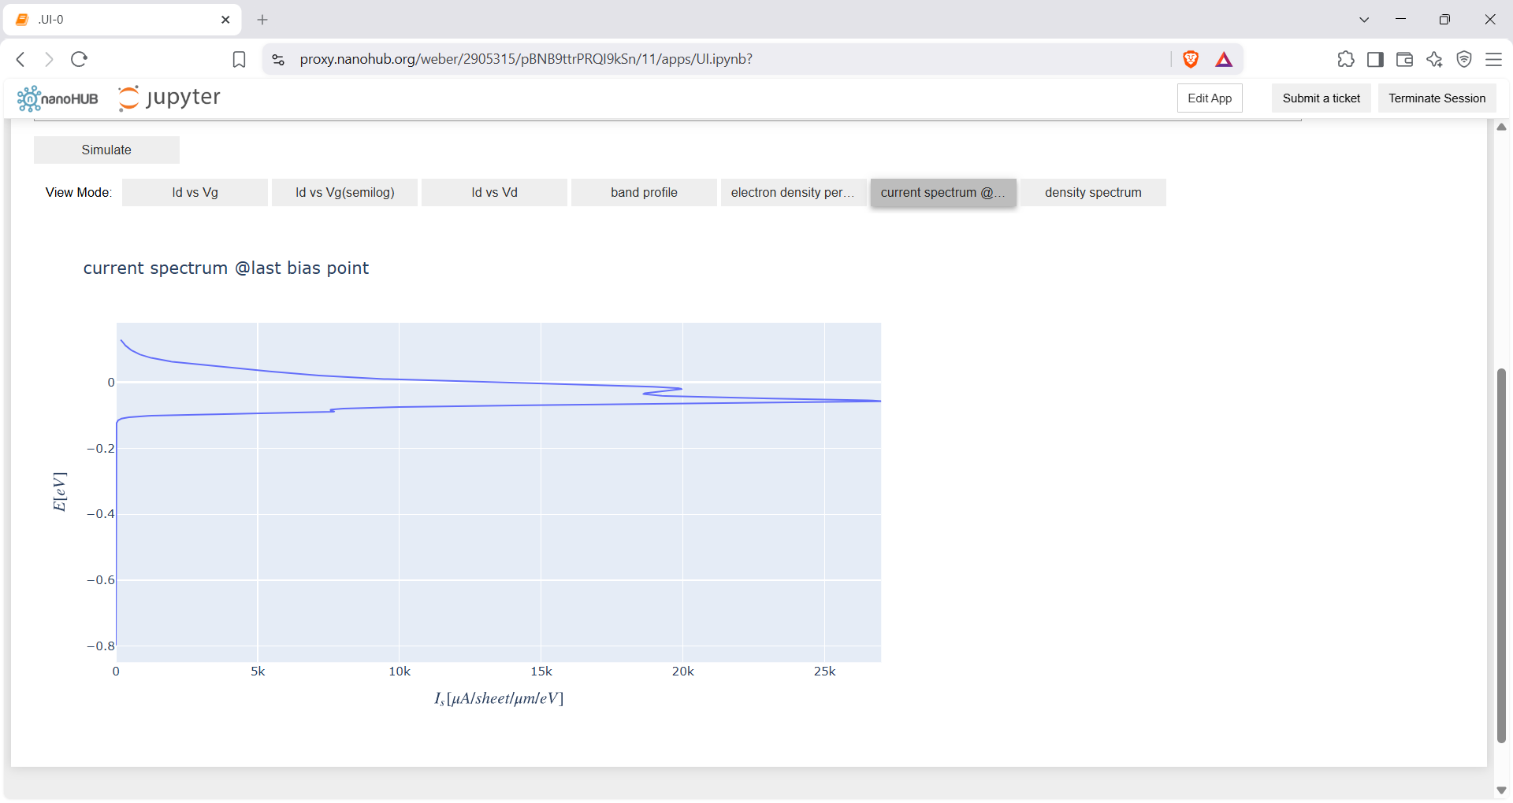

Case Study 2: Simulate & obtain the electron density per sheet characteristics of FinFET. Analyze its performance with different Gate region length

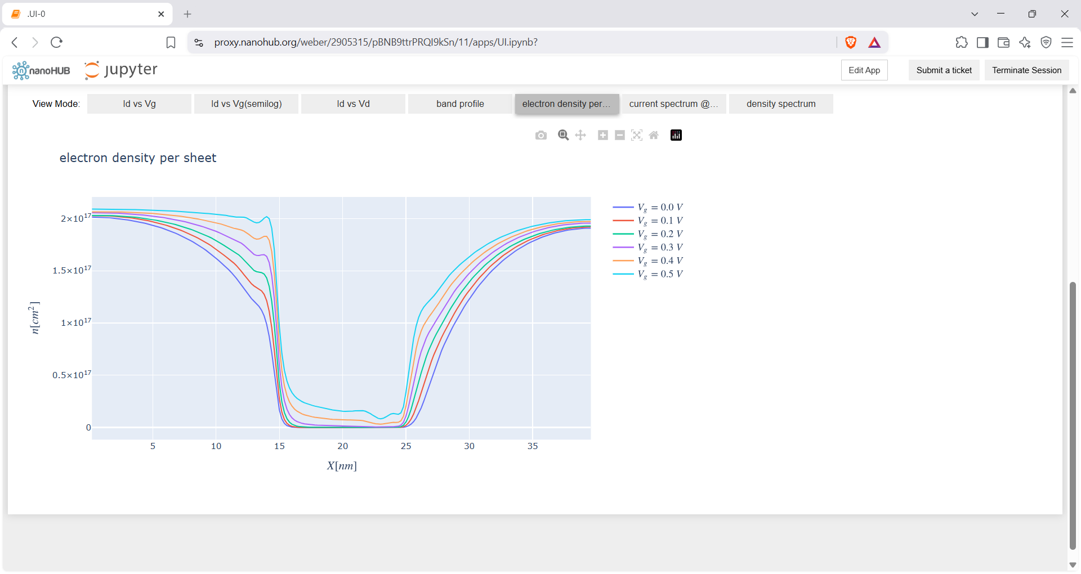

- CNTFET

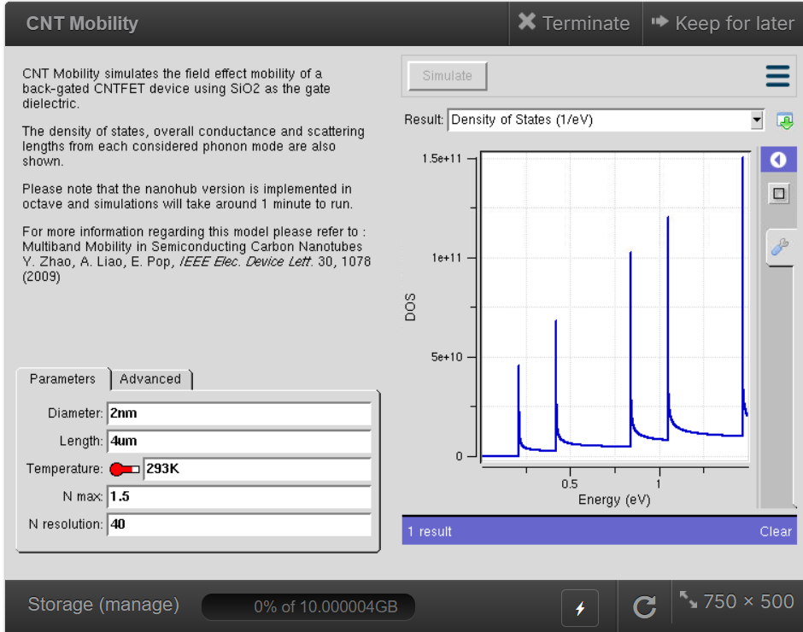
Density of states

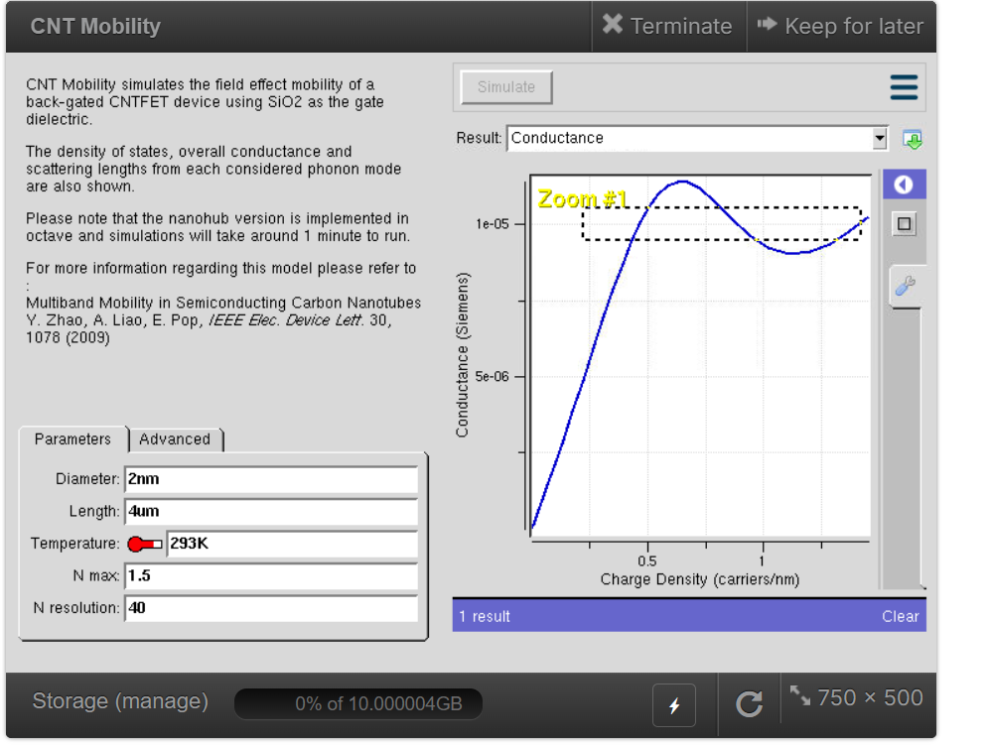

Case study 1: Simulate & Obtain the VI characteristics of CNT-FET by varying Schottky
barrier and oxide thickness

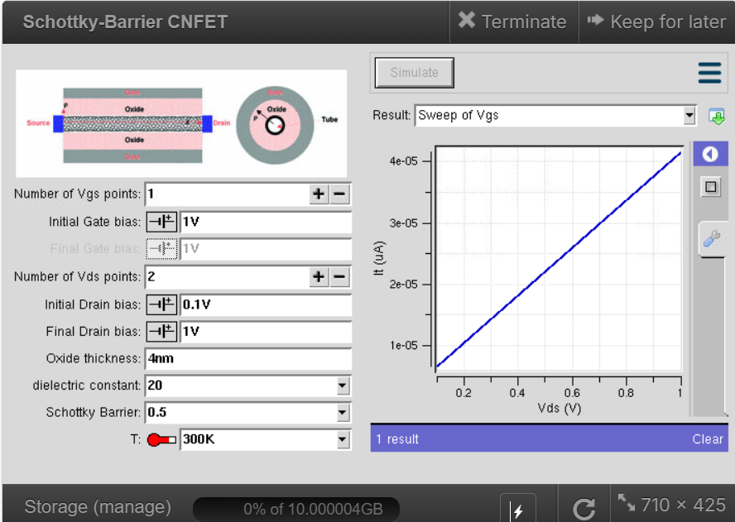

- GFET
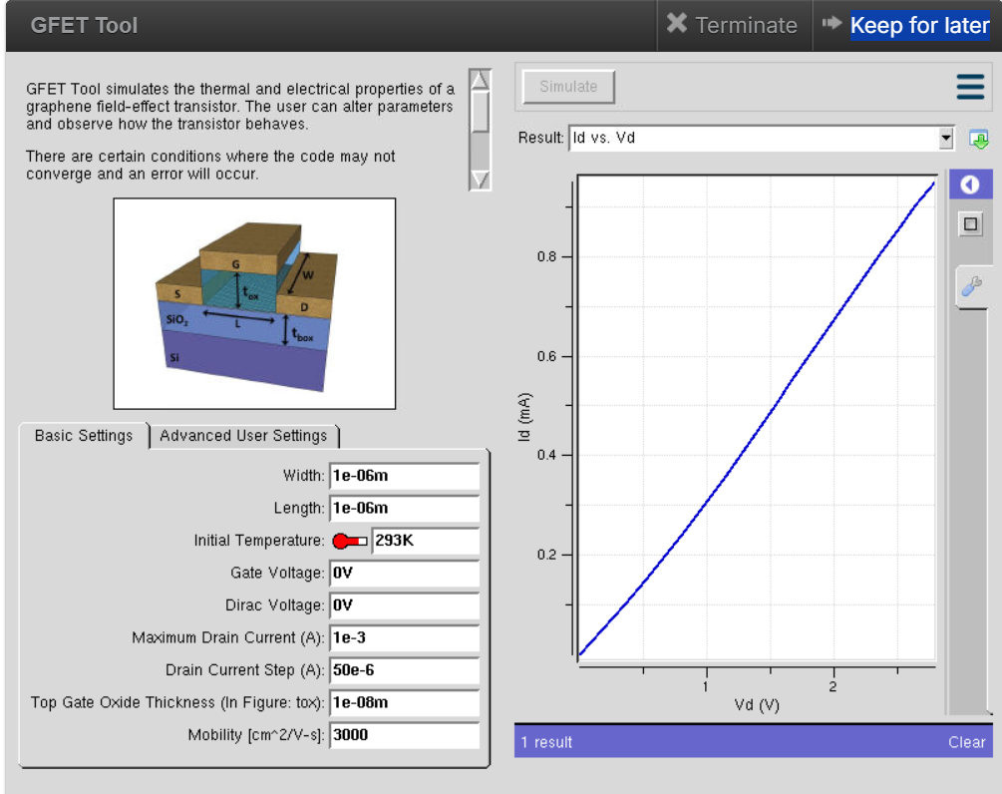

Exp. 9. Simulation of Tunneling Magnetoresistance (TMR) by Varying Barrier Height
using NanoHUB

Case Study 1: Characteristics of TMR with barrier height of 0.85eV
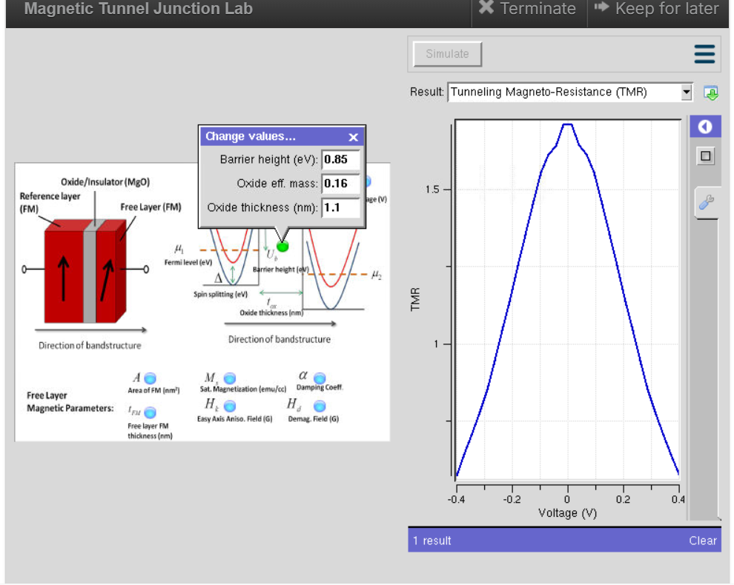

Case Study 2: Characteristics of TMR with barrier height of 1.0eV
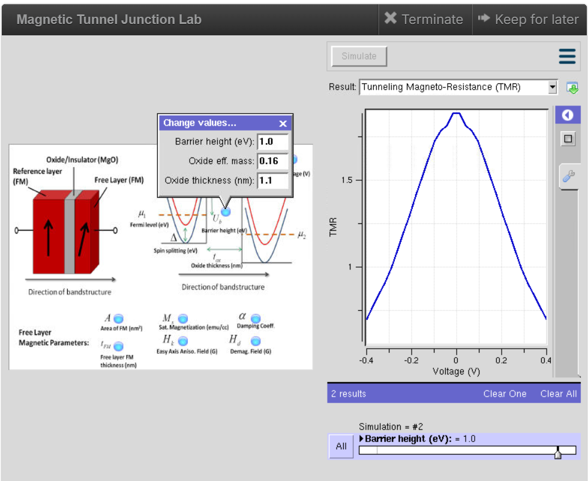

Exp. 10. Biosensor and Bio-FET characteristics using NanoHub

